APPLICATION FORM FOR PARTICIPATION
AT THE 10th INTERNATIONAL PUPPET FESTIVAL OF KALAMATA
10-18 OCTOBER 2026


Organized by:

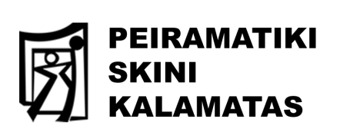

Dear artists,
Those of you from Greece or abroad who are interested in participating in the 10th International Puppet Festival of Kalamata, programmed to take place from 10 to 18 October 2026, we invite you to fill in the following questionnaire in word format in English and to send it back to us the soonest possible and at the latest by the end of December 2025 to the following e-mail addresses: puppetfestkalamata@gmail.com and Pei.ski.kal@gmail.com

APPLICATION FORM

For the theatre company:
- Name of the theatre company:
- Biography:
- Address and postcode:
- Phone number:
- E-mail:
- Website:
- Contact person:

About the performance
- Title:
- Summary of the performance (maximum 100 words):
- Author-idea:
- Scenario:
- Direction:
- Constructions, animation:
- Music:
- Lighting:
- Duration of performance:
- Photography:
- Artistic techniques:
- Age of audience:
- Number of audience:
- Number of members of the theatre company:
- Video of performance (mandatory, even if amateur):
- High-resolution photographic material in image format:
- Link of trailer of the performance:

Technical specifications
- Indoor or outdoor venue:
- Stage length/depth/height:
- Setup time:
- Teardown time:
- Other stage requirements:
- Lighting - Sound requirements:
- Estimated cost:
- Travel expenses:

The 10th International Puppet Theatre Festival of Kalamata will take place from 10-18 October 2026:
In which of these days you will not be able to perform?
NOTE: please attach the video, preferably of the entire performance and photos which will be used exclusively for the selection of the performance by the festival committee.

Please fill in all the details of the online form in English in Word format.
All the best,
From the Kalamata Experimental Stage
and the Organizing Committee of the Festival
Contact e-mails:
puppetfestkalamata@gmail.com and Pei.ski.kal@gmail.com

